**Architecture Design**

**Project Title: Investment Analytics**

**Architecture**

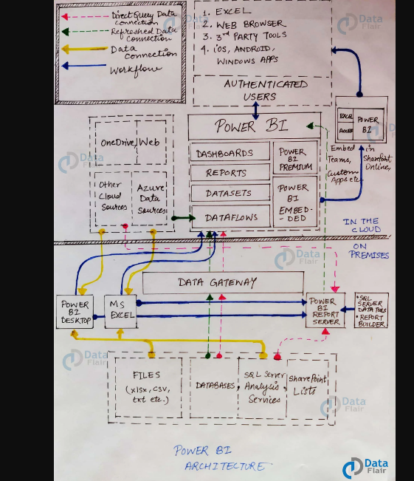

**Power BI server Architecture**

**On-Premise:**

Power BI Desktop is accomplished with the authenticating, development and publishing tools. You can transfer the data from data sources to Power BI Desktop. And also, it allows users to create and publish reports on the Power BI Report Server or Power BI Service.

Power BI Publisher allows you to publish the Excel workbooks to the Power BI Report Server. Report Publisher and SQL server Data tools help in creating the KPIs, datasets, paginated reports, mobile reports, etc. All kinds of reports are published at the Power BI Report Server, and from there, reports are distributed to the end-users.

**On-Cloud:**

Power BI Gateway is the essential component in the Power BI architecture. The Power BI Gateway acts as a bridge or secure channel to transfer the data from On-premise data to On-cloud data sources or apps.

Cloud side architecture consists of a lot of components including Power suite having datasets, dashboards, reports, Power BI Premium, Power BI Embedded, etc. Users can embed the dashboards, reports into applications, SharePoint, Teams, etc. There are Cloud data sources and they are connected to the Power BI tools.

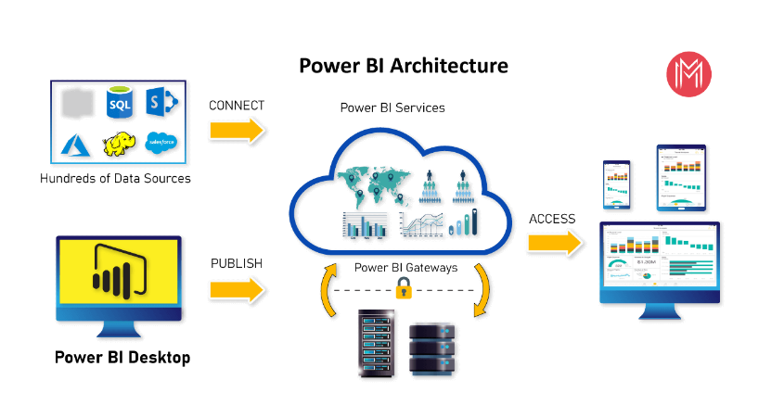

**Power BI Communication Flow**

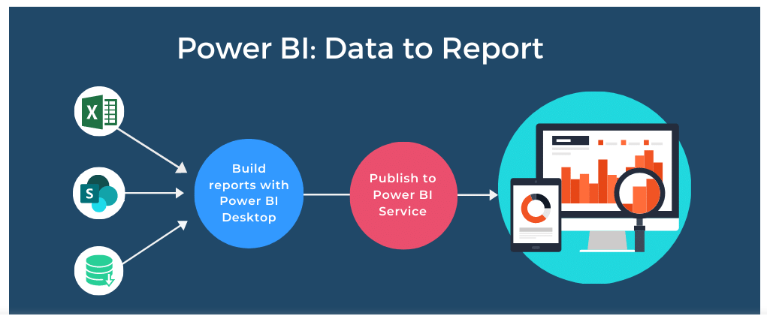

**Deployment Description**

There are four connectivity types that can be used for interacting with the underlying data source, with each having its own benefits and limitations. Connectivity types can also alter the functionality available for use in Power BI Desktop, hence it is important to make sure we select the connectivity type most suited for our purpose early on**.**

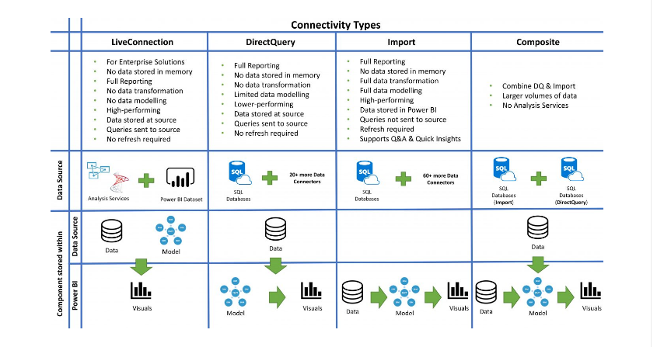

**Power BI Pro and Free**

Power BI Pro is the most popular Power BI licensing option. It allows you to share and collaborate with all the end-users covered by your organization’s Power BI license. Unlike Power BI Free, you can publish reports to the Power BI Service.

A Power BI Pro license gives you a maximum dataset size of 1GB and maximum storage of 10GB per user. You can refresh datasets up to 8 times per day. Power BI Pro is part of the Office 365 Enterprise license. Otherwise, it costs $10 per user per month. If others want to view your reports, they will need a Power BI Pro license as well.

You get a maximum dataset size of 10GB and up to 48 dataset refreshes per day. You also access advanced features such as AI and machine learning cognitive services, paginated reports, deployment pipelines, and automatic page refresh. Additionally, Power BI Premium includes a report server.

Keep in mind that even if you have a Power BI Premium license, you still need a Power BI Pro license to publish reports to the Power BI Service. However, users with the Power BI Free license are able to view the reports within your Power BI Service tenant.

